To: Housing Panel (Panel of the Scrutiny Committee)

Date: 9 March 2016

Report of: Oxford City Council Communities and Housing & Property Services

Title of Report: Security issues in the tower blocks and the different approaches being taken to address anti-social behaviour and other issues in the communal areas.

Summary and Recommendations

Purpose of report: To identify the frequency and types of issues in the tower blocks, and activities to address them.

Key Decision: No

Executive Lead Member: Councillor Dee Sinclair, Executive Member for Crime and Community Response

Policy Framework: Corporate Plan priorities – Strong, Active Communities; Cleaner, Greener Oxford

Recommendations:
- support the continued engagement with residents and the local community on security concerns
- Support the implementation of additional security improvements.

List of Appendices

Appendix One (page 5): Foresters Tower PSPO
Appendix Two (page 8): Evenlode Tower residents feedback
Appendix Three (page 9): Youth Appreciative Inquiry Feedback

Introduction

- This report was commissioned to investigate how to improve the security of residents living in Oxford’s tower blocks. There are five tower blocks in Oxford City:
  - Evenlode Tower, Blackbird Leys – 60 households with some privately owned flats.
  - Windrush Tower, Blackbird Leys – 60 households with some privately owned flats.
  - Hockmore Tower, Cowley – 57 households with some privately owned flats.
  - Foresters Tower, Wood Farm – 85 households with some privately owned flats.
  - Plowman Tower, Northway – 85 households with some privately owned flats.
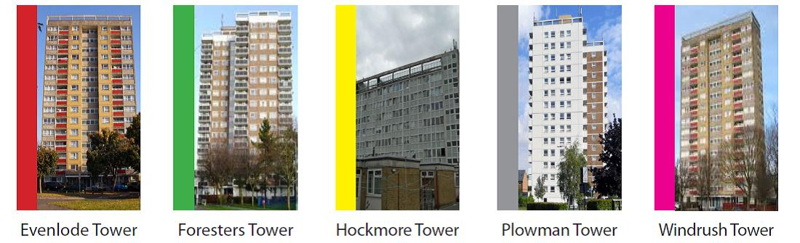
- Living in a tower block differs from living in a conventional house or flat. There is increased security to flats above the ground floor, internal lifts and rubbish chutes and a dedicated Estate Officer. All the tower blocks also have electronically controlled entry and CCTV.
- All tenants are jointly responsible for the environment in their tower block. The tenancy agreement states that:

18. LIVING IN A FLAT OR MAISONETTE

18.1. If you live in a flat block, tower block or first floor maisonette there are added conditions because of the design of your home.

18.2. You must keep the shared areas secure by using the security systems properly and not letting strangers in without identification.

18.3. You must not block, obstruct, create or leave any hazard on landing, corridor, stairwell, lift, refuse chute, access way, fire escape or any other shared area or wedge open fire door or security door. This includes, but is not limited to personal items, washing, household rubbish, bikes, pushchairs, mobility scooters, plants and pet cages. We will remove any blockage, obstruction or hazard we find in shared areas and charge you for any costs that we incur.

18.5. You are not allowed to use a barbeque or patio heater on or directly beneath balconies.

18.13. Throw anything out of the windows of the property or from balconies or landings.

18.14. You and anyone living with or visiting you must not smoke in any shared area, including shared balconies, lobbies and staircases.

- There have been a number of reports of anti-social behaviour (ASB) to the council and police in Foresters Tower, Evenlode Tower and Windrush Tower. No recent reports have been received concerning Hockmore Tower or Plowman Tower.
- Oxford City Council is investing a substantial amount of money in the refurbishment of the tower blocks in the city. The refurbishment includes structural repair work, external insulation and cladding to enhance and extend the lifespan of the blocks, refurbishment of the lifts, improved fire detection and alarm systems, new external windows and doors and new front lobbies.

Foresters Tower

- In the summer of 2014, residents of Foresters Tower were experiencing on-going ASB from groups of young people aged between 13 and 17 who have been gathering in the communal hallways within the block.
- Partner agencies including the police problem-solved the issues and decided to consult on a Public Spaces Protection Order (PSPO) legislation in conjunction with referrals into youth engagement activities.
- The PSPO consultation process ran from 8th December 2014 to 23rd January 2015. Each household within the tower block was contacted by Council officers from the council’s Anti-Social Behaviour Investigation Team (ASBIT) and Community Response Team, and local neighbourhood police officers.
- Households that didn’t engage were given a letter explaining the reason for the consultation and encouraged residents to report any incidents. In the letter residents were asked if they wanted to set up a residents association or community watch but there was little interest in setting up either scheme.
- The initial investigation in to the reports of ASB centred on diary statements, police reports and CCTV evidence to identify those involved. A group of approximately ten young people were identified and their families contacted. Some parents were given Community Protection Notice (CPN) warnings and the young people were asked to sign Acceptable Behaviour Contracts (ABCs). This is a voluntary agreement prohibiting them from entering any of the tower blocks or flats in the area unless they had a legitimate reason for the visit.
- The families who engaged in the ABC process were referred for support from Oxford City Council’s Youth Ambition programme.
- A PSPO for the tower block was implemented on the 20th February 2015. To ensure that the behaviours do not disperse outside during summer months the area has included the internal and external public areas.
- The order was publicised through the local press, social media, residents’ publications, leaflets to residents and posters displayed in prominent areas of the building.
- This order was one of the first PSPOs in the country, introduced by the ASB, Crime and Policing Act 2014.
- Since the 20th February 2015 there has been only one report to the council or police of ASB in the tower block. The incident was not linked to the original group and due to the publicity on how to contact ASBIT was reported and investigated quickly. Regular meetings of the Neighbourhood Action Group and continued meetings with the police team have identified no further ASB issues and there has been positive feedback from local residents.

Evenlode and Windrush Towers

- Groups of youths aged between 13-19 years old have been gaining unauthorised access to Evenlode and Windrush towers in Blackbird Leys causing concern to the tenants.
- On the 1st October 2015 Oxford City Council’s Tenancy Management Officer and Localities Officer called on every household within the tower block asking residents if they had any concerns (Appendix Two). It is clear that residents are not reporting the incidents to either the police or the council, although they are more likely to report issues arising on their floor of the building rather than stairwells, lifts and communal areas.
- On the 15th December 2015 ASBIT organised an Appreciative Inquiry (AI) for young people at the local community centre. The event was prepared in partnership with the Localities Officer, CRT, Community Development Initiative, local college and Youth Ambition Team. The local police were not invited at this time.
- The AI engaged with a difficult to reach group who were aged from 13 – 17 years. The event received 16 confirmations but on the day five young people attended. However, the information gained was very useful (Appendix Three) and has led onto the creation of a Youth Forum, supported by the Youth Ambition Team. Another AI, led by ASBIT, will be held in the local college during school time.

Current Interventions

- The police Neighbourhood Team have access to both tower blocks via a key fob and the Oxford City Council weekend Out of Hours officers are tasked to visit, resulting in groups being removed from the blocks.
- A letter has been hand delivered to all residents advising them to contact Thames Valley Police to report any ASB issues.
- Regular reviews of CCTV footage helped identify a number of people involved in recent incidents. A variety of actions were deployed:
  - Some young people were offered Acceptable Behaviour Contracts (ABCs).
  - Referrals to Social Services and TVP where appropriate.
  - Letters to parents and home visits were conducted on all individuals.
  - Regular engagement by the police with youths in the area.
  - Referrals to the Youth Ambition Programme. Many of the young people were already engaging with local organisations.

Recommendations

- Improved security - identified as a concern from the consultation on the tower block refurbishment, conducted by the Tenant Involvement and tenancy Management Teams. The refurbishment and additional lobby will improve security in the tower blocks.
- Referrals into early intervention activities - working with parents, schools, Youth Ambition Team and local clubs to divert youths from the tower blocks.
- ASBIT have engaged with a number of outside agencies for support and advice on youth engagement, such as the charity “Voice of Child”.
- Support for the youth forum and future AI’s on issues identified by young people.
- Continued enforcement actions –
  - Acceptable Behaviour Contracts
  - Community Protection Notices for parents and youths over 16 years
  - Injunctions
  - Consideration of a Public Spaces Protection Notice, similar to Foresters Tower
  - Criminal convictions or referrals to the Youth Offending Service
  - Criminal Behaviour Orders

Name and contact details of author:-
Name Daryl Edmunds
Job title Anti-Social Behaviour Team Leader
Service Area / Department: Community Services
Tel: 01865 252723; e-mail: dedmunds@oxford.gov.uk

List of background papers: none

Version number: v1.0

